**Lab # 5: Connection of C# Application Forms with SQL Server**

#### Objective:

To make the windows application forms in C# and connect them to SQL Server.

#### Scope:

The student shall know the following:

* SQL Commands. •

C# Programming

* Hands-on experience with the above- mentioned concepts.

#### Discussion:

We have studied the SQL commands in detail and C# programming, now we will make a form in visual studio using C# and then connect it with SQL Server which is our database.

### Creation of Form in Visual Studio:

Open visual studio 2019, the screen is shown below will appear.

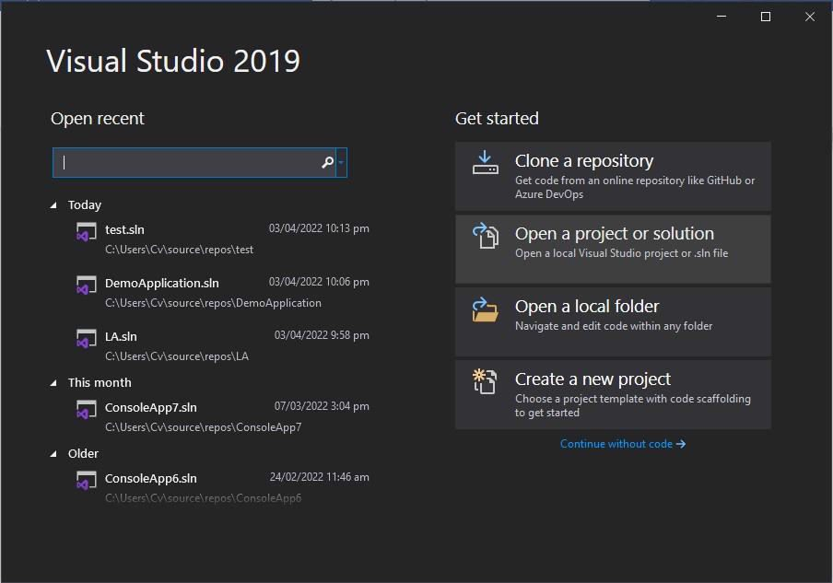

Click on the **Create a new project.** After clicking on that write in the search box **Windows Forms App** as shown on the screen below.

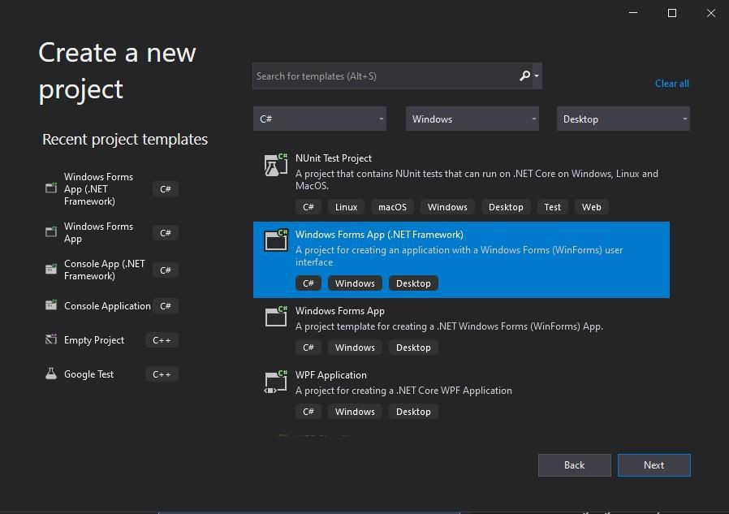

Choose the highlighted option and click on the **Next** button. The screen shown below will appear. Write the name of the form and location and then click on the **Create** button.

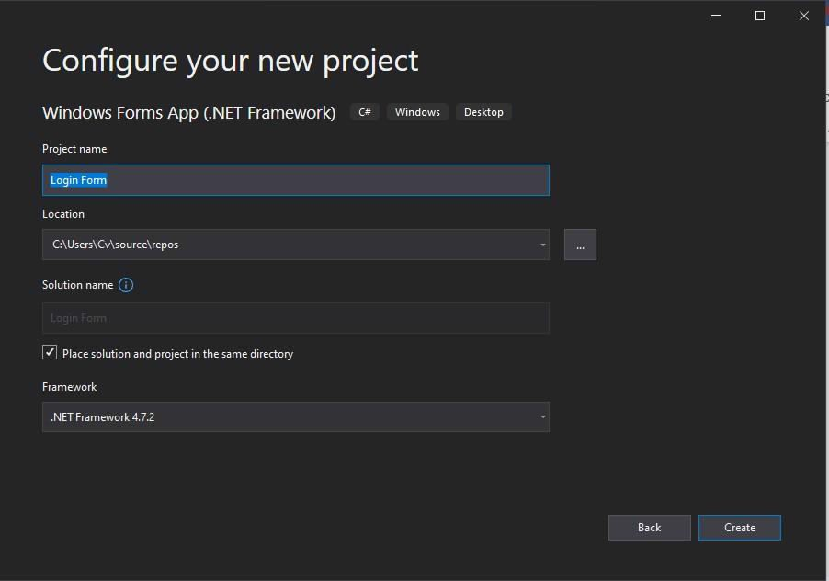

Your blank form is created successfully. You will see the screen as shown below.

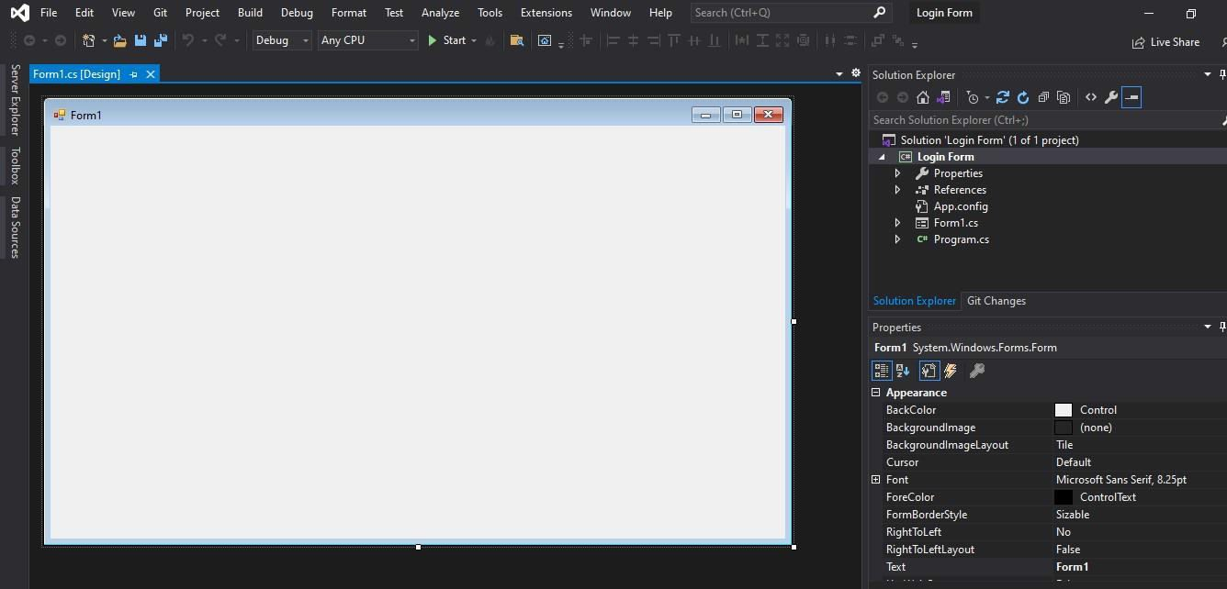

Now you have to create the login form for this insert labels, text boxes, buttons, etc. according to your requirement in the black form. You can insert it from the option on the left of the screen **Toolbox**.

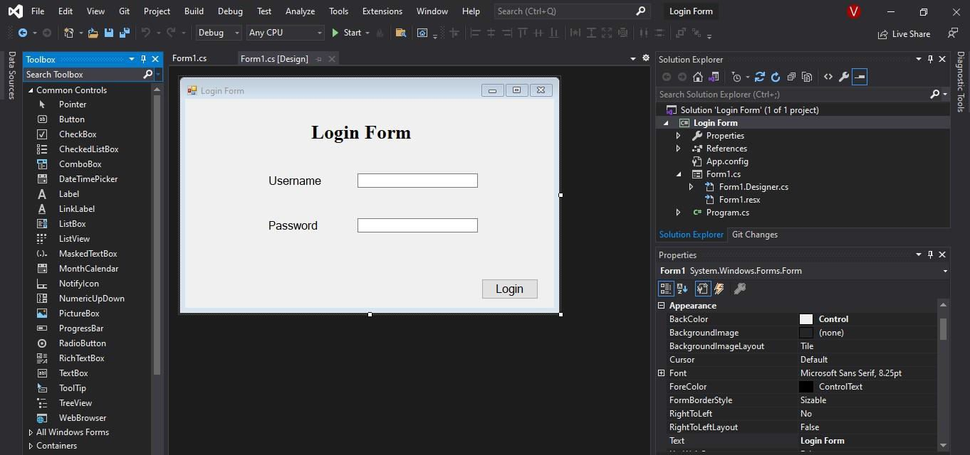

The login form is successfully created by just drag and dropping the required controls. The color, font, and other properties of the form can be changed through the property panel present in the right corner of the visual studio.

Now the 2nd task is to create the database for this form using an SQL server.

### Creation of Database in SQL Server:

Open the **Microsoft SQL Server Management Studio** and click on the connect button. After clicking on the connect button all the objects will appear on the left of the SQL server screen. I have created the database named “pos_db” as shown in the screen below.

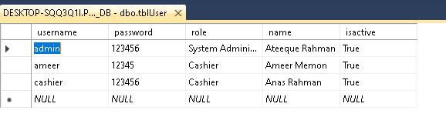

### Connection of C# Form with SQL Server:

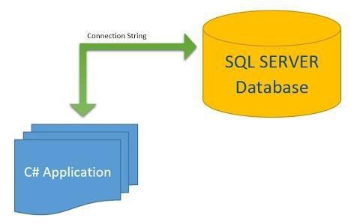

Open the visual studio and at the top of the option, there is the option **Tools** click on that and then click on **Connect to Database**. Now the screen shown below will appear.

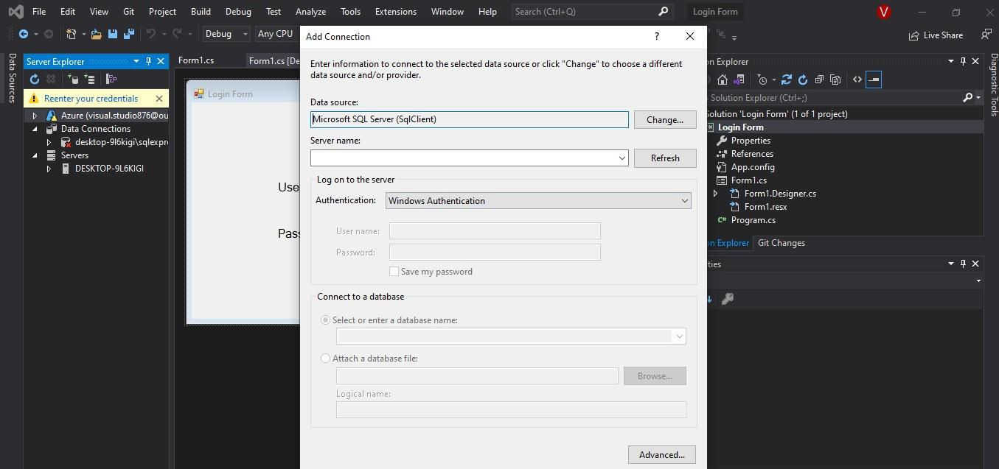

Now you have to enter the server’s name. For this open the SQL server and at the top of the

SQL Server right click on the highlighted option and click on the connect.

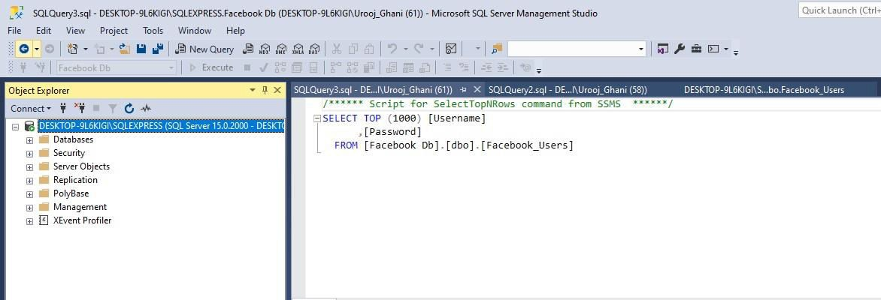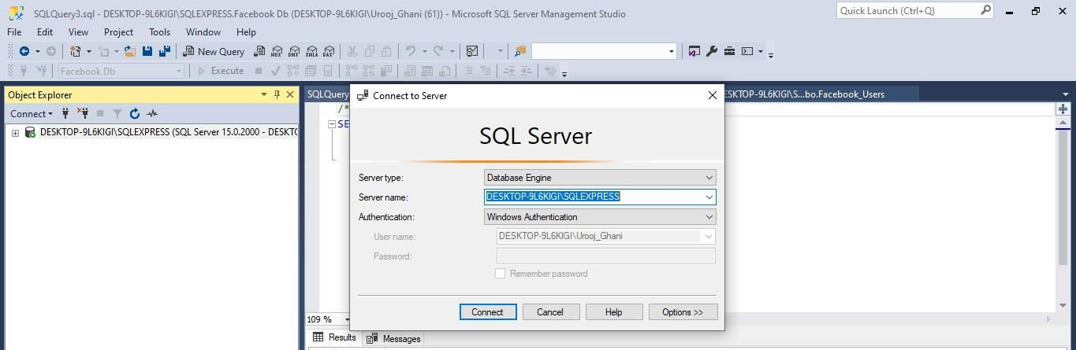

From this screen copy the server’s name and insert it into the visual studio server name. When you insert the server’s name then a radio **button selects or enters a database name** that will be enabled as shown below. Choose the name of the database to which you want to connect. My database name was Facebook Db, so I choose it.

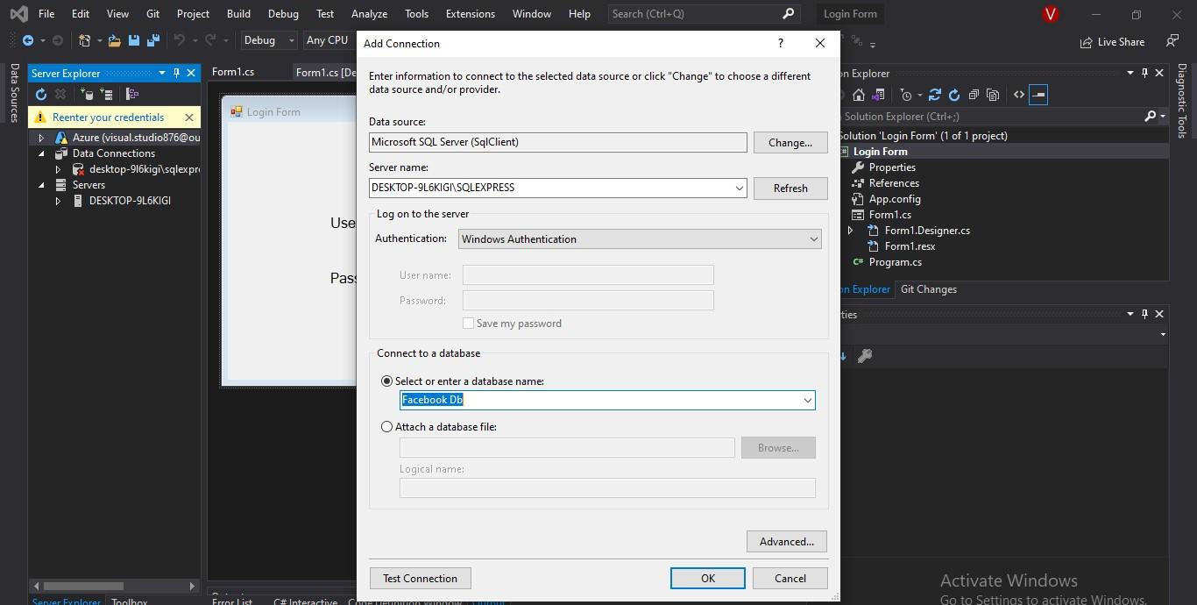

Click on the OK button. Now in the left panel of the visual studio under Server Explorer, in database connections, your server has been loaded as shown below. Now you can check the table by clicking on the server name and table.

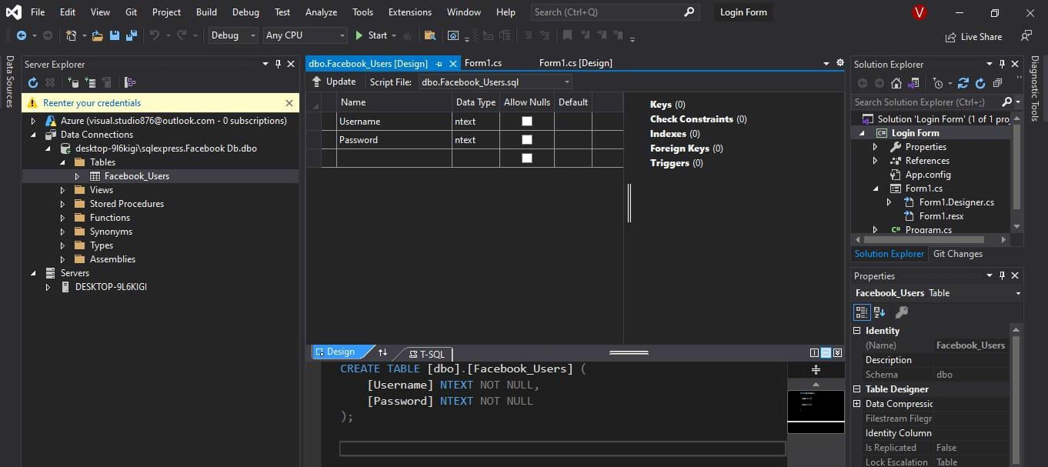

The SQL Server is successfully connected to the C# Application Form. Now we have to add an action listener in the button login, which means that when the user enters the data, the data must be inserted into the table. For this open the form design and double click on the login button, it will move you to the code section and write the code given below. Add the library at the top of the code “using System.Data.SqlClient;”. If you do not add it, then your code will give errors.

### Create DB Connection file:

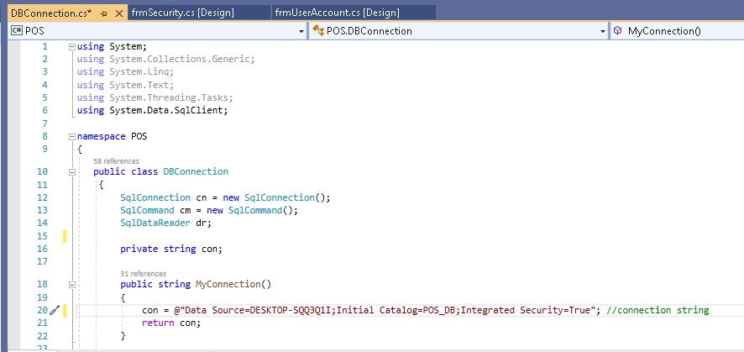

1. **Login Form:**

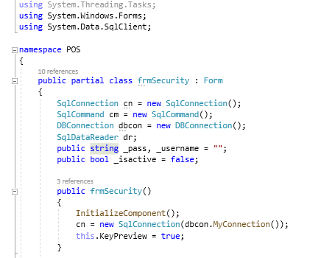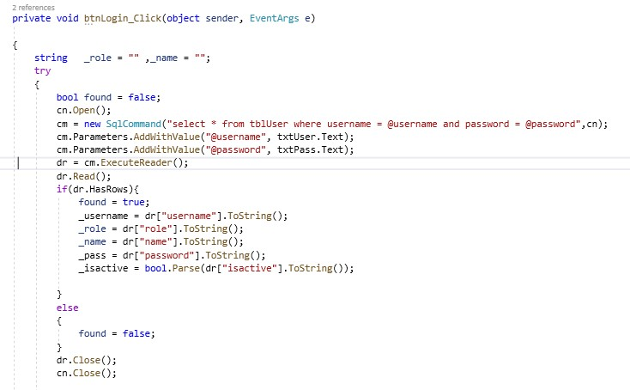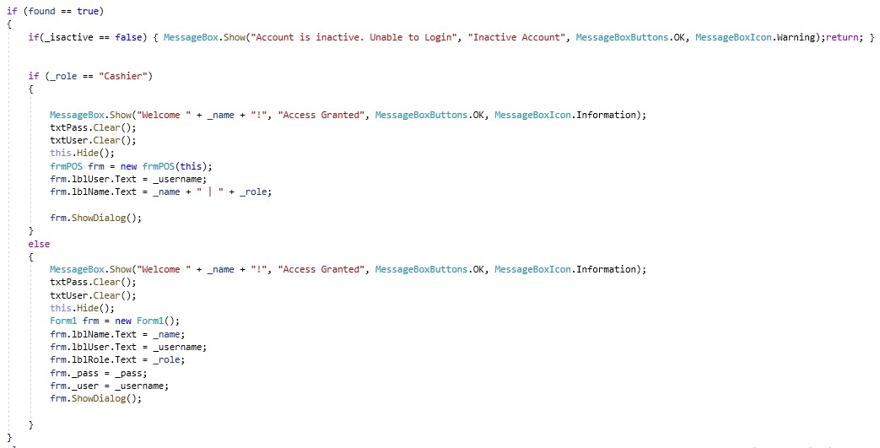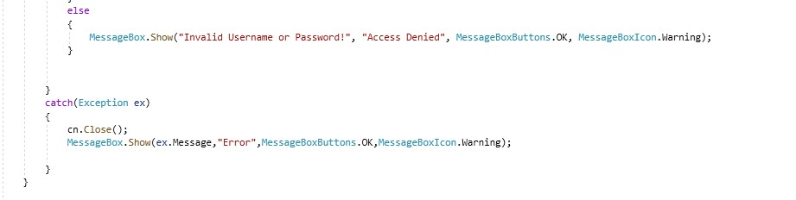

1. **Signup Form**

